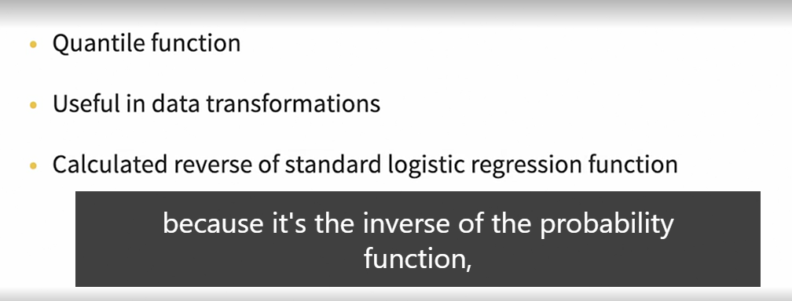

IF a Logistic Function/cumulative distribution function tells :

Given a value x, what's the probability that a random variable is less than or equal to x

THEN Quantile function asks :

given a probability p, what’s the value x such that the probability of being less than or equal to x is p

Quantile Function is reverse of standard logistic expression associated with sigmoid curve also often called Odds-Logs Function

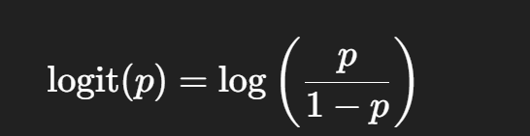



**The B’s (B₀, B₁, B₂)**

* **B₀** = Intercept (bias)
* **B₁, B₂, ...** = Coefficients/weights for features
* Tell the model **how much each feature matters**

# Mean when Actual outcomes aren’t available

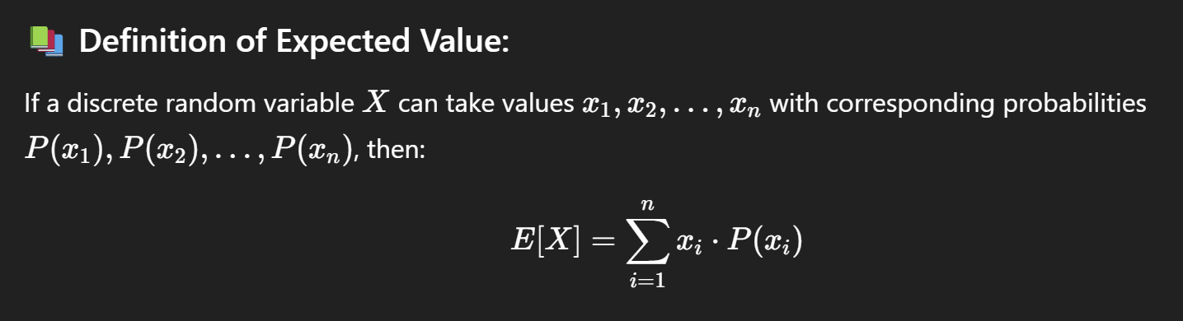

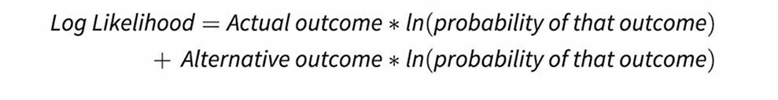

We need to Maximise Sum Of Log Likelihood so as to make most optimal model and more optimal sigmoid curve

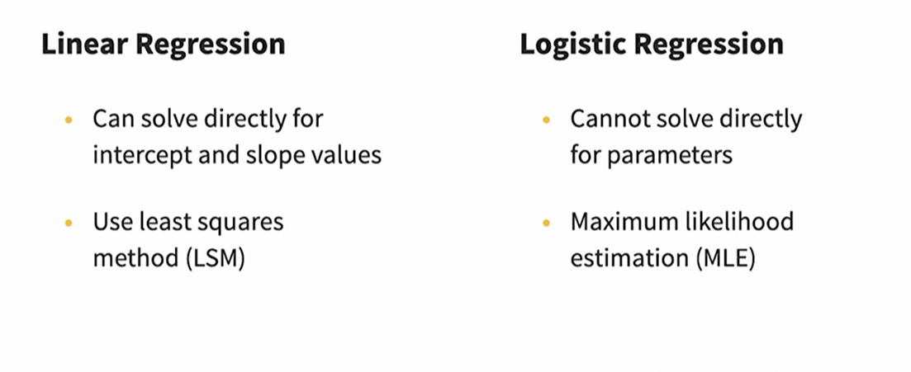

Both LSM and MLE are used to find the best suited parameters

# LSM for linear regression model

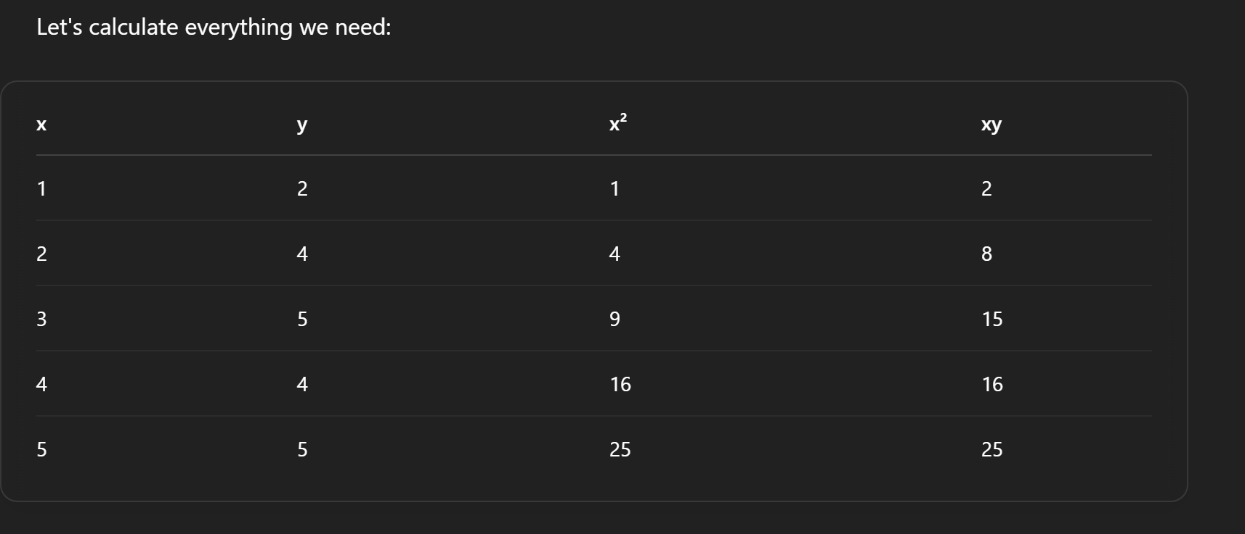

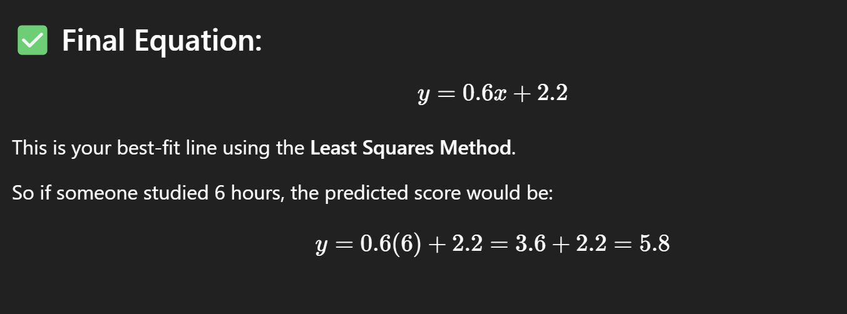

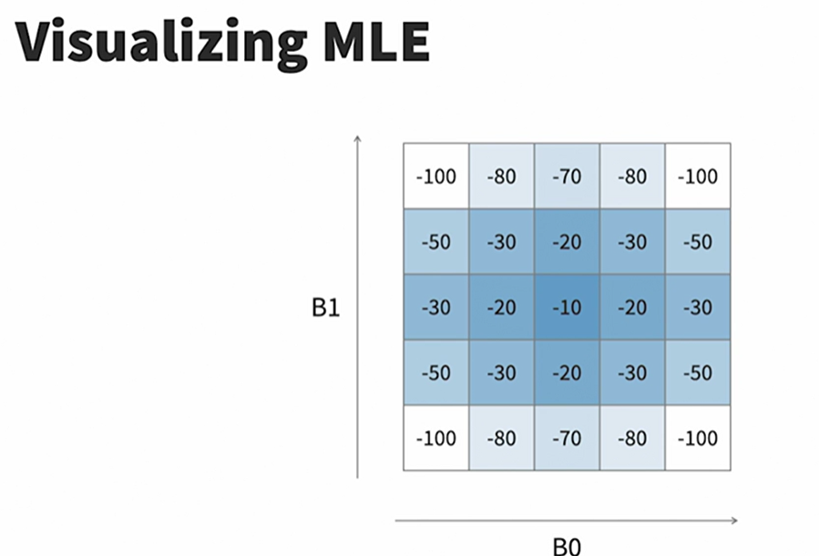

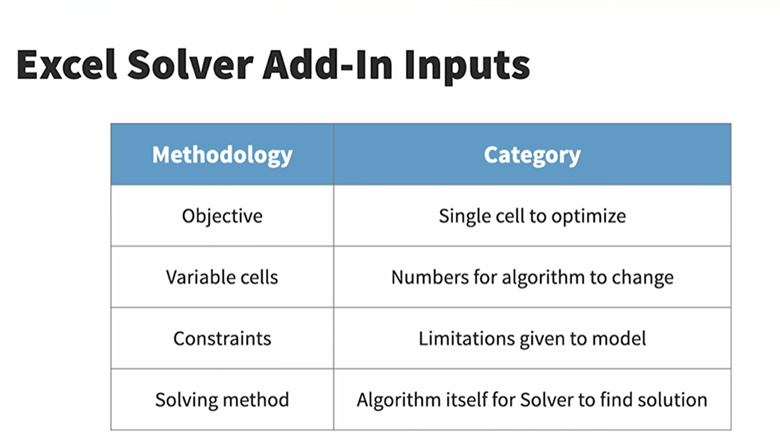

Similarly Python GLM Model also provides logistic regression model